What Is AIOps, and Why Do Companies Need It?
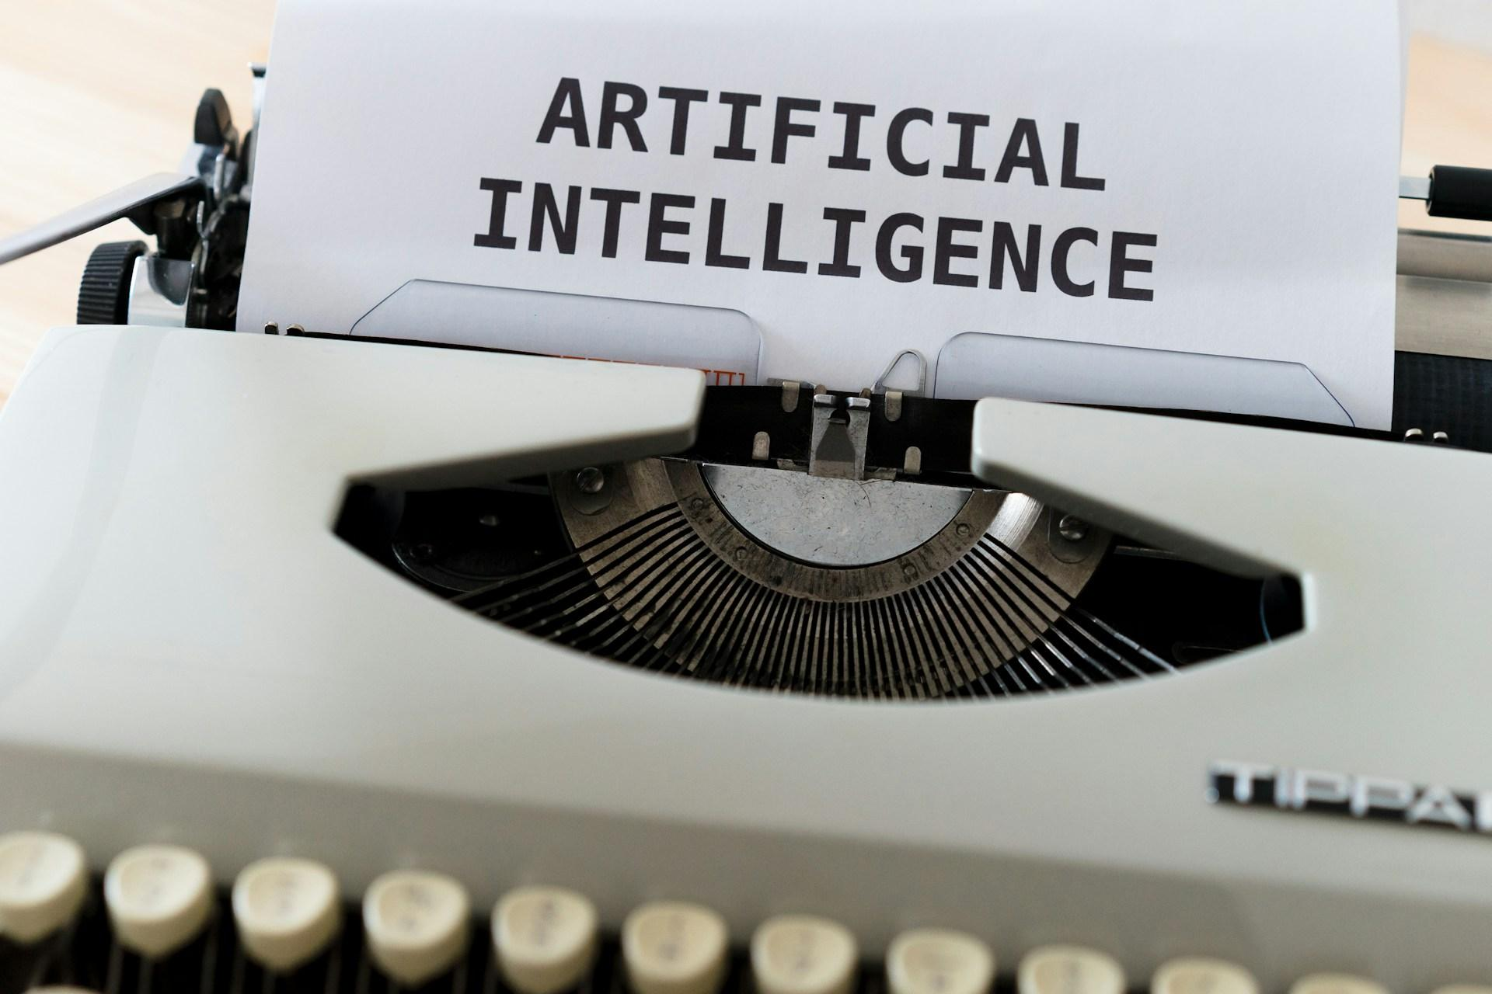
Source: Unsplash
AI has found its way into every nook and cranny of the business world a lot faster than expected. From customer service chatbots and sales support to personalized recommendations and fraud detection, technology has become the lifeline of modern businesses. Thanks to AI powering smarter decisions and faster responses, many business operations and logistics now run smoothly around the clock. But this is not all AI has to offer companies.
Currently, there is one area in which AI is quietly making a massive impact: IT operations.
IT operations is one of the most complex, critical, and resource-intensive functions within any organization. From maintaining servers, connecting networks, to monitoring applications and ensuring systems are secure, available, and performing optimally, IT operations are the invisible force keeping the business engine running. In fact, businesses rely heavily on IT systems to stay connected, and as they scale, so does the complexity of their IT infrastructure. This is where AIOps comes in.
AIOps, short for Artificial Intelligence for IT Operations, is one of the most significant innovations in enterprise technology in recent years. It brings the power of machine learning, data analytics, and automation to the heart of IT systems. In this article, we break down how AIOps is gaining so much attention, why it is becoming a necessity, and why companies need to adopt it.

What is AIOps?
First coined by Research Firm Gartner in 2016, AIOps, or Artificial Intelligence for IT Operations, combines AI-driven insights and analytics with traditional IT operations. In many ways, it is similar to how DevOps (Development and Operations) brought together development and IT teams to improve software delivery. AIOps, on the other hand, is all about transforming how companies manage, maintain, and maximize their IT operations. AIOps is changing the game when it comes to collecting, analyzing, and acting on large volumes of data.
With the use of advanced technologies like machine learning, big data analysis, and automation, AIOps helps companies maintain uptime, respond to incidents, and keep systems running smoothly at scale.

Source: Unsplash

Why Do Companies Need AIOps?
Now, to the big and perhaps the most important question asked by many: Why do companies need AIOps?

Proactive Issue Detection and Resolution
One thing companies cannot afford is downtime or slow responses. It is safe to say that experiencing downtime or lag is the same as losing customers and money, even if it happens for a few minutes. In today's digitally fast-paced world, customers expect apps and services to work instantly - metaphorically, at the speed of light. Anything short of that, and they move on.
Even with modern and up-to-date monitoring tools in place, the reality is that IT-related alerts only come in after something breaks. By that time, customers are already affected, and the brand has taken a hit. This is one area where AIOps takes the lead in. It detects issues, unusual behavior patterns, such as a server gradually running out of memory, and recommends actions or automatically fixes the issue before it escalates.
To put it simply, AIOps reduces Mean Time to Detect (MTTD) and Mean Time to Resolve (MTTR), allowing businesses to stay always-on.

Saves Time by Automating Routine Tasks
In the business world, time equals money, and that is why time is always well accounted for. It is a resource that cannot be replenished, so how it is spent matters. Repetitive tasks like performance monitoring, log analysis, manually sifting through data, and responding to every minor glitch take up valuable time. More often than not, they keep IT teams stuck in a cycle of firefighting rather than focusing on strategic improvement. It is important to note that doing the same thing over and over again, even if it is their job, can be demoralizing.
Over time, it leads to burnout, lower job satisfaction, and a drop in productivity, which negatively affects the company. AIOps helps solve this by automating routine and repetitive tasks. It takes the manual load off the IT professionals, freeing up their time to tackle higher-level problems and come up with solutions to improve the overall operation of the company.

Boost Better Customer Experience
At the heartbeat of every thriving business is a series of impressed customers. By detecting and resolving issues in real time, AIOps helps ensure that customers rarely feel the impact of technical problems. More importantly, AIOps allows companies to be proactive, not just reactive. It does not wait for complaints to roll in; it identifies potential issues before they become customer-facing problems.
With AIOps, your company can maintain uptime, experience less customer frustration, and build trust with your customers. This level of operational stability is not just a nice-to-have; it is a business necessity.

Reduces Alert Fatigue
Ask any IT engineer, and they will tell you, dealing with constant alerts is exhausting. Many alerts are false positives or duplicates, and they bury the real problems under a mountain of noise. AIOps tools reduce this burden by using machine learning to filter, correlate, and prioritize alerts. Instead of hundreds of meaningless alerts, the system may generate just one or two meaningful incidents that need human attention.

Staying Competitive
Companies that thrive are the ones that adapt, innovate, and deliver a flawless user experience. Aside from that, the integration and use of trending AI-powered tools and systems in the company's operations give it a clear competitive edge. It should go without saying that today's business environment moves fast.
If your competitors are using AIOps to detect issues, optimize performance, and maximize their IT operations, and you are not, you are already behind. This is not a case of "do as they do," rather, it is a case of doing what is necessary to stay relevant and boost your company.

The Skepticism of Companies around AIOps Adoption
Despite the growing interest in AIOps, there is still a level of skepticism among many companies, especially when it comes to fully integrating AI into core operations. While many companies are already using AI-powered tools, they are often more hesitant to fully integrate their IT operations with automated systems. The skepticism and caution are understandable. Entrusting AI with essential operational functions for your company can feel risky, especially with the reports of false positives, data management challenges, and uptime and security on the line.
However, there is one thing to note: AI enhances, not undermines. It takes care of the hard-to-tackle tasks and leaves the rest to you. It breaks down the complexities of your IT operations into simpler bits to boost your productivity and competitive level in the business world. AIOps is not without its challenges, but so is every modern or traditional tool used in the business.
This should not be a reason to hold back on one of the best AI-driven insights your company needs.

Are AIOps Replacing Humans?
Not at all.
AIOps is not about replacing IT professionals; instead, it is about empowering them. In fact, one of the biggest strengths of AIOps is its ability to work alongside humans. The AI learns from IT teams’ past decisions, and teams can train it to align with business rules and policies. So instead of being a threat, AIOps actually makes IT operations in companies more effective, more agile, and more valuable.

Conclusion
AIOps is not just another tech trend; it is a necessary evolution in how organizations can approach performance, reliability, and innovation in their IT operations. By combining AI, machine learning, and automation, AIOps can help companies deliver a better experience for both employees and customers. Without a doubt, AIOps will continue to reshape and redefine IT operations – the question now is, will your company be a part of it?

